1. **Agenda**:
   1. How to deal with CORS and CSRF which are very related to Spring Security.
2. 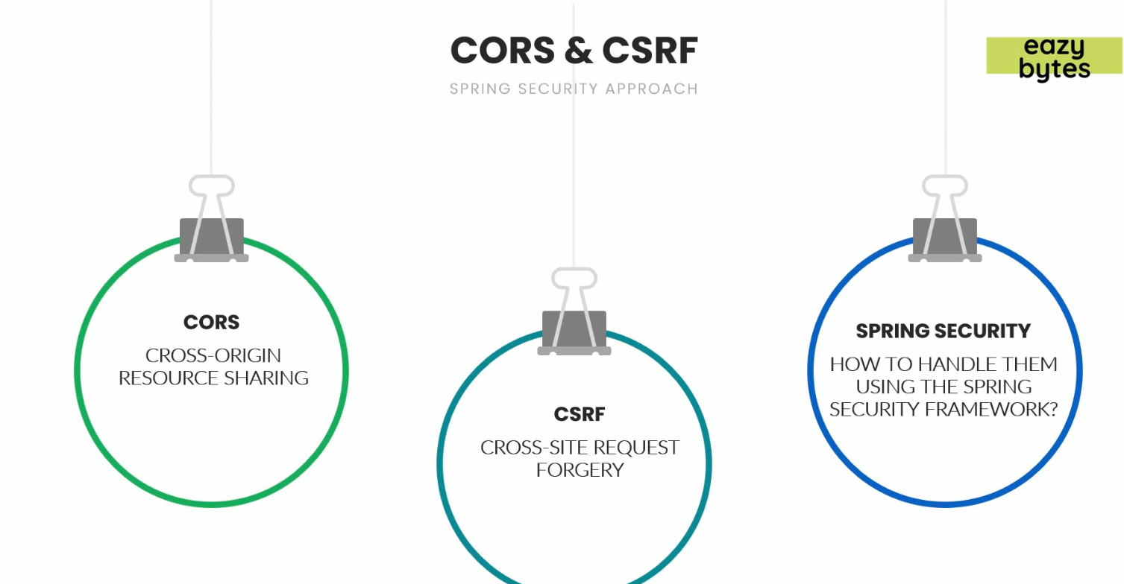
3. We will run front-end app and back-end app.  
   During the request from front-end to back-end, we will encounter CORS and CSRF kinds of security problems.  
   We will see how to handle it.  
   